Create and Configure IBM services IOT Watson Platform

|  |  |
| --- | --- |
| **TITLE** | Gas leakage monitoring and alerting system for Industries |
| **DOMAIN NAME** | INTERNET OF THINGS |
| **TEAM ID** | PNT2022TMID38796 |

Step1: Log in your registered id

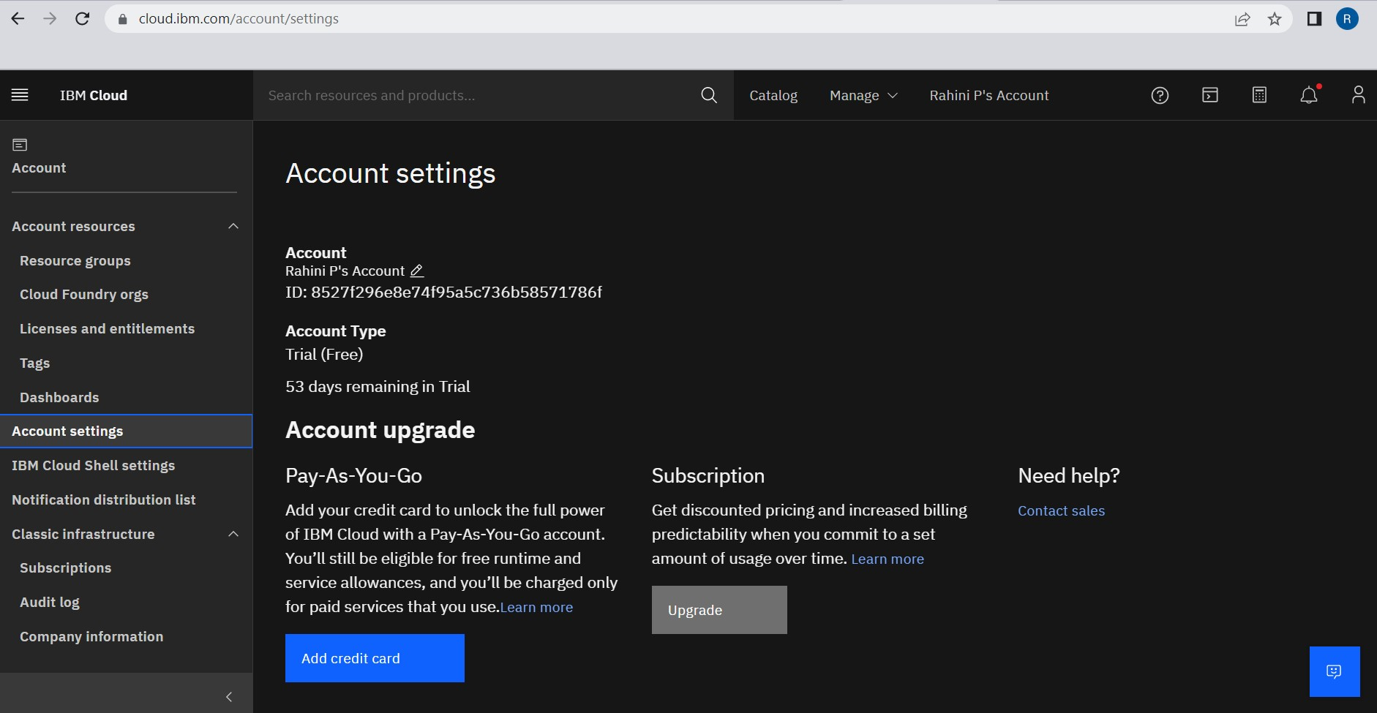

Step 2: click catalog where you find the services and internet of thing you can select and make location as London

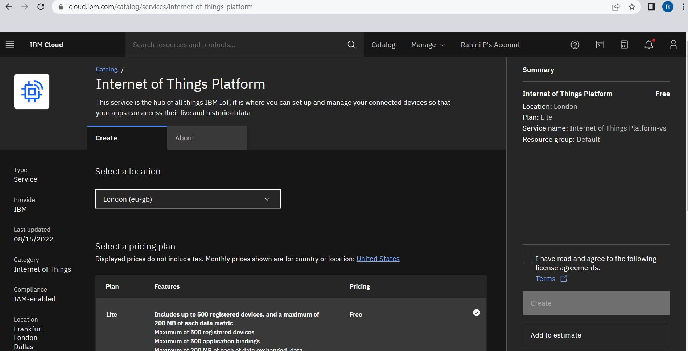

Step 3: click create and the launch tab get open, then click launch

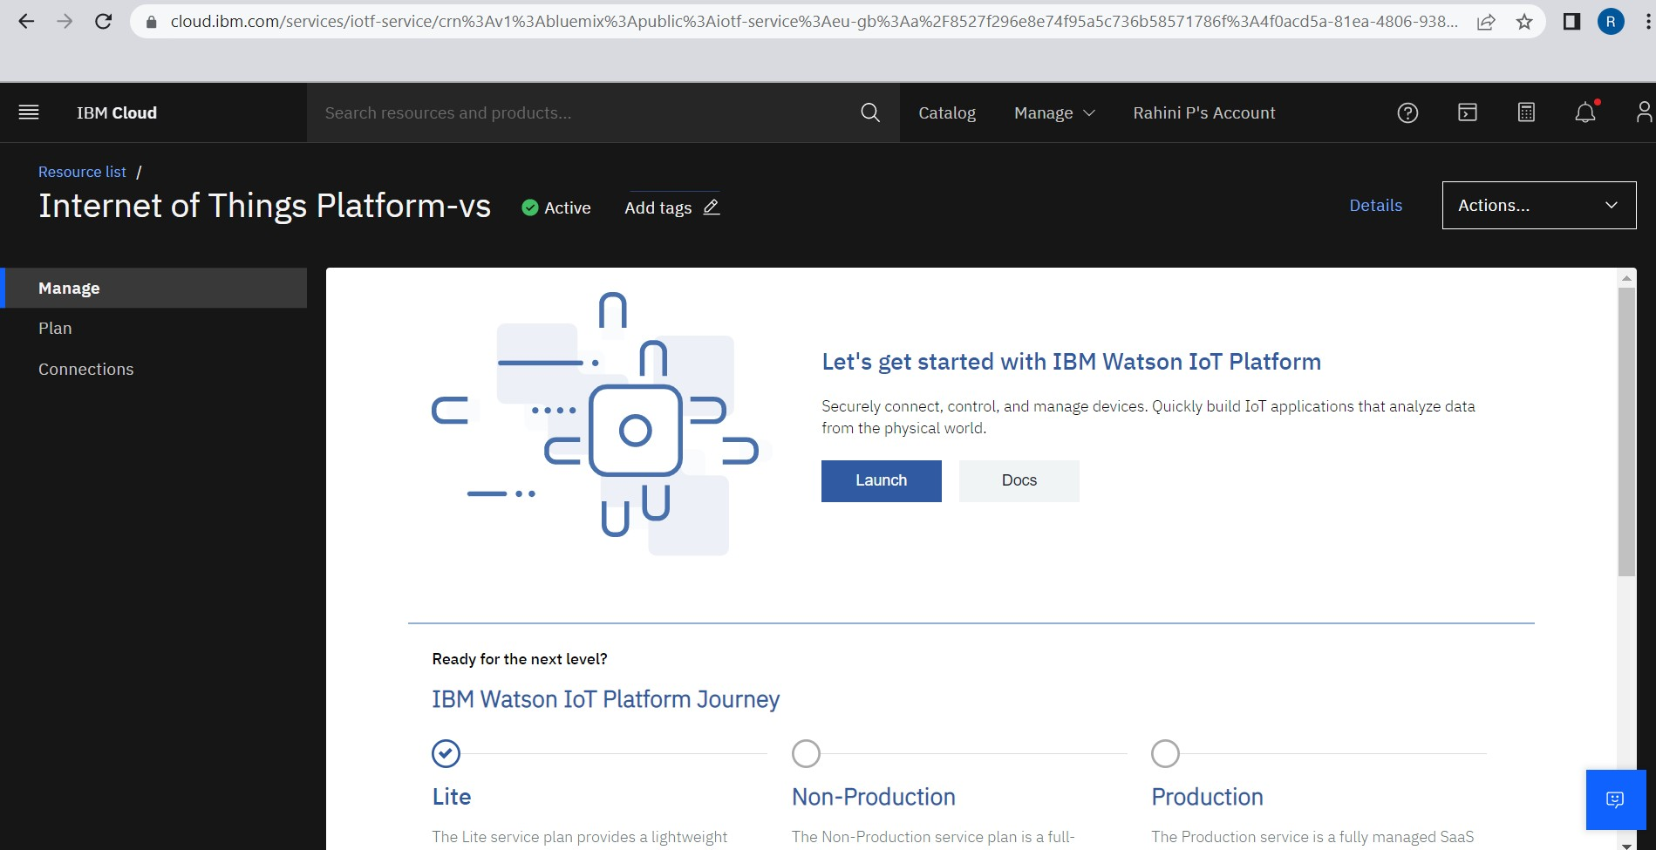

Step 4: It redirect you to IBM WATSON platform where you need to click sign in

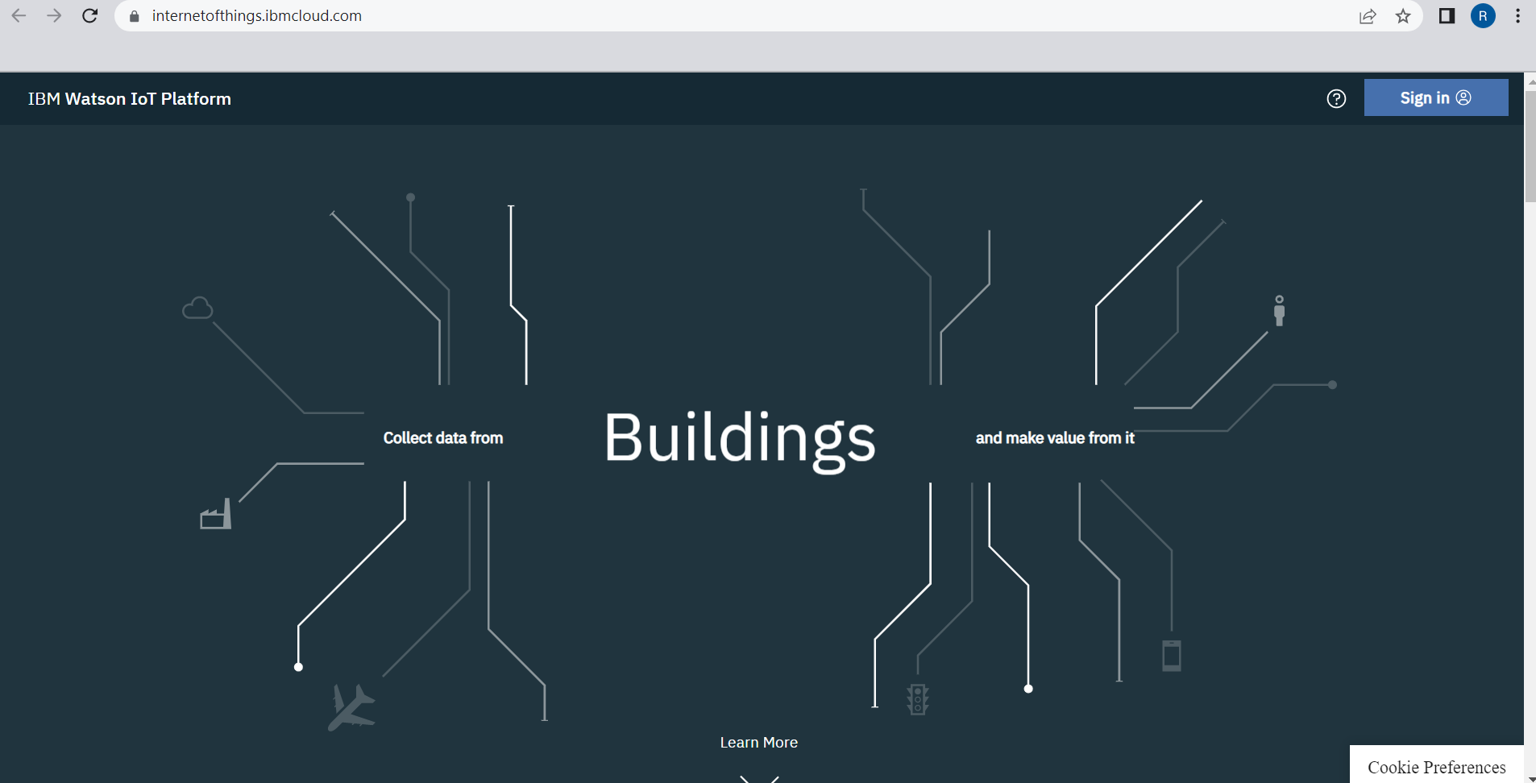

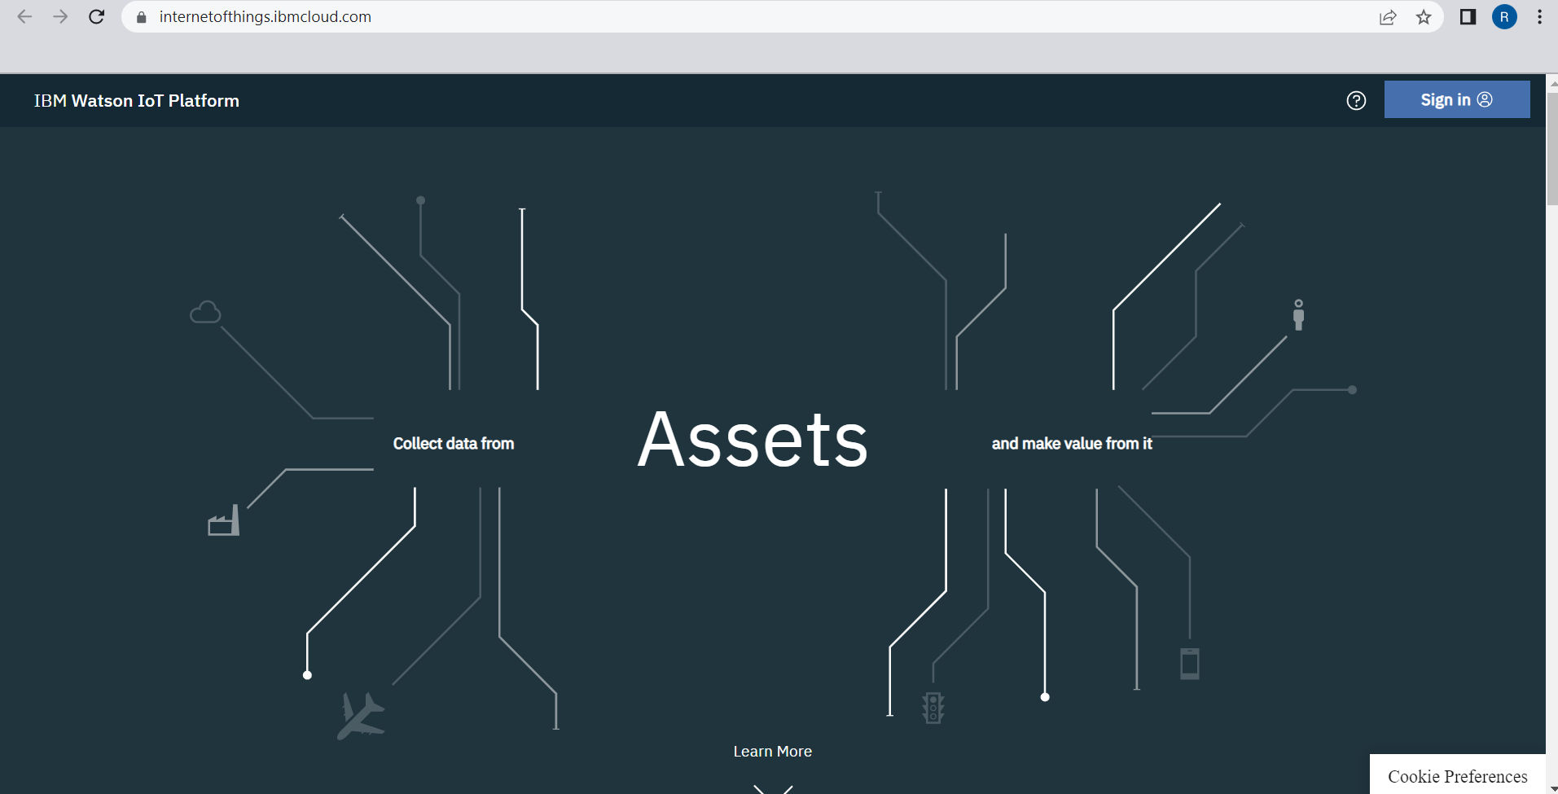

Step 6: where you find this tab which is used to add device, app, member, usage, and security can be worked

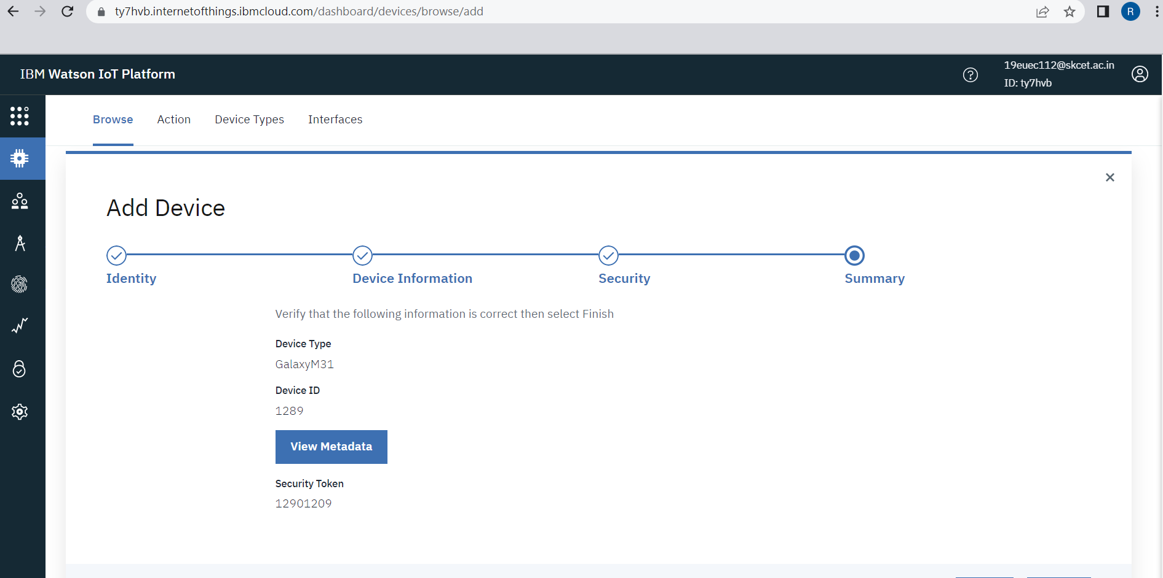

Step 7: check boards for risk and security overview card, it uses for graphical representation boards

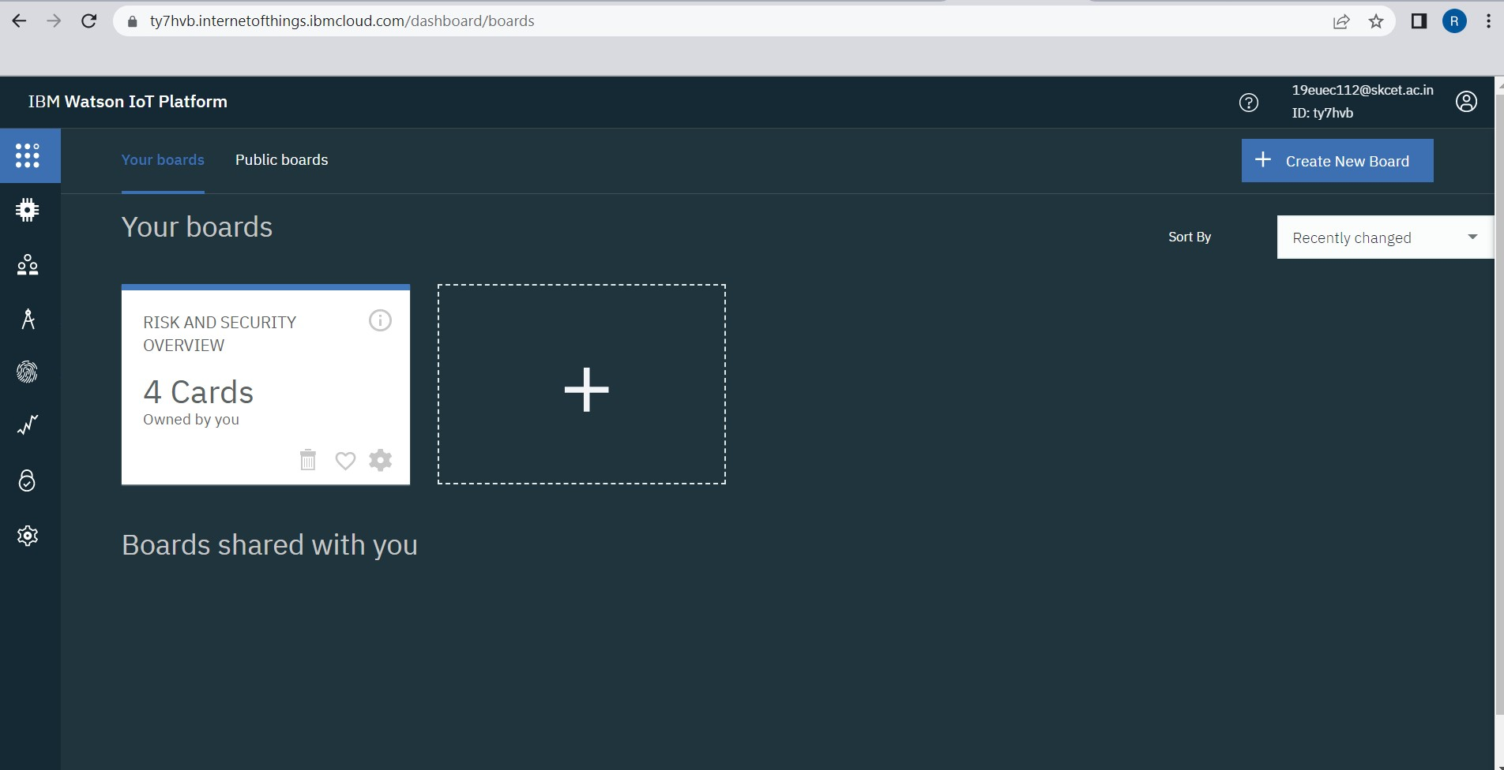

Step 8: after clicking create a new device / add device you can choose an device type and device id and complete the following information to create a device

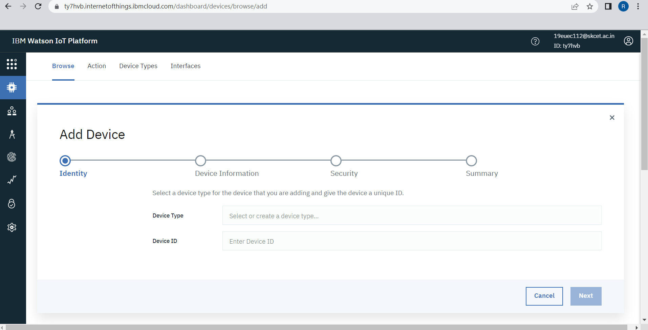

Step 9: created a device of NodeMCU

